MEMORY STONES
Plain-Language Library
The words the work needs, said plainly.
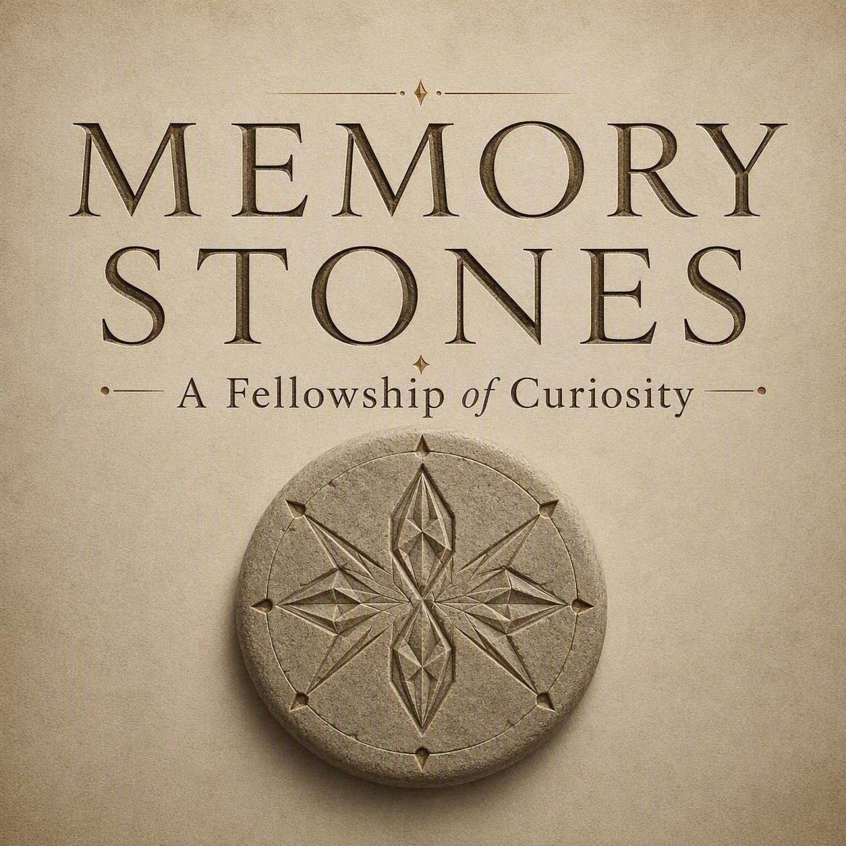
This is not the first doorway into Memory Stones. The visual episodes are.
Use this library when a name would help you recognize something you have already encountered. It is not assigned reading, and it is not a map of terms to learn in advance.
Experience first. Recognition afterward. Reference last.
Memory Stones helps people recognize what lived experience contains, discern what is worth carrying, preserve what remains meaningful or unfinished, and voluntarily offer wisdom forward so others may draw from what experience has already tested.
The entries follow the path, not the alphabet. Names arrive when you reach them.
Stills appear where a Traveler is likely to encounter the practice. Evidence, stewardship, and archive terms remain text-led unless a visual helps recognition.
A mark (†) means the name lives in the Curiosity Compendium, not in this Library.

I. The Invitation
01 WONDER PORTAL PRACTICE / INVITATION
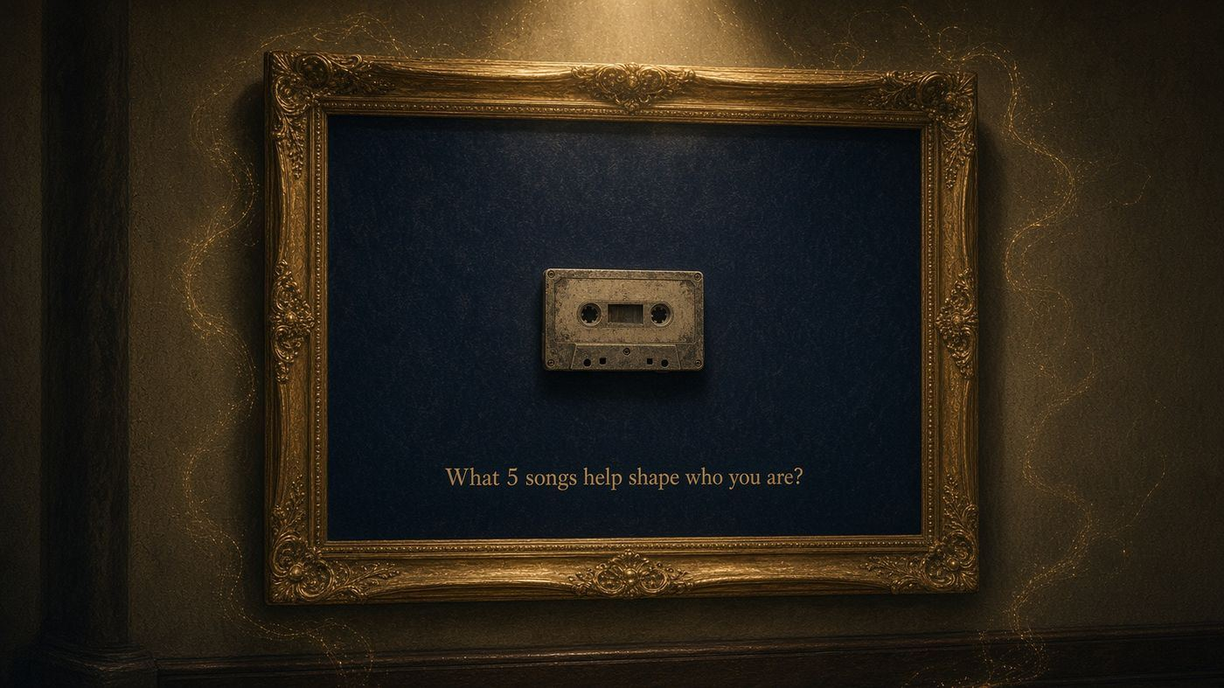
SAY IT PLAINLY A designed invitation that catches attention and opens curiosity before a conversation begins.
PICTURE THIS An ordinary object, image, place, or question causes someone to pause and look again.
DO NOT CONFUSE IT WITH A poster, survey, command to participate, or answer disguised as a question.
A Wonder Portal begins the conversation before the conversation.
TRAVELS WITH Wisdom Wellspring; Wonder Break

02 WISDOM WELLSPRING LIVING QUESTION LIBRARY

SAY IT PLAINLY The named library where Wonder Portals and better questions are gathered and stewarded.
PICTURE THIS A Traveler needs an entry point and draws an invitation suited to the moment.
DO NOT CONFUSE IT WITH A library of answers, a shortcut around inquiry, or a prompt dump.
The Wisdom Wellspring is where the Fellowship goes to draw better questions.
TRAVELS WITH Wonder Portals; Curiosity Compendium

03 TRAVELER JOURNEY LANGUAGE
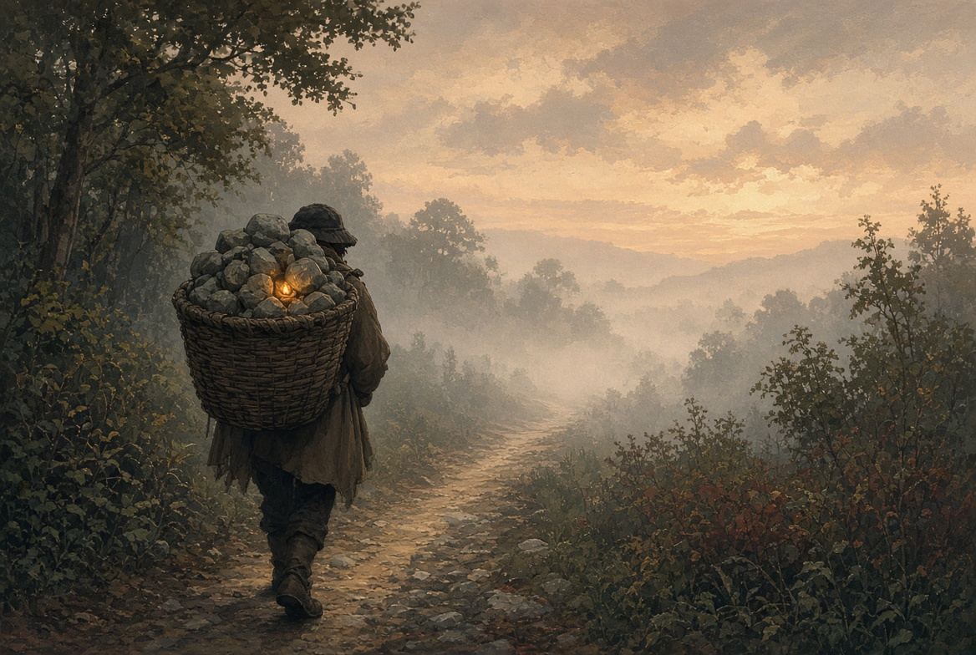
SAY IT PLAINLY The person moving through the experience and retaining authority over what meaning fits, what is contributed, and how far anything may travel.
PICTURE THIS Someone arrives carrying a question, burden, memory, assumption, or possibility and chooses the pace.
DO NOT CONFUSE IT WITH A participant to be studied, a source to be mined, or a passive recipient of expert interpretation.
The Traveler carries the experience and remains its steward.
TRAVELS WITH Explorer†; Quarry; Traveler Artifact; Consent

04 QUARRY HOLDING PLACE
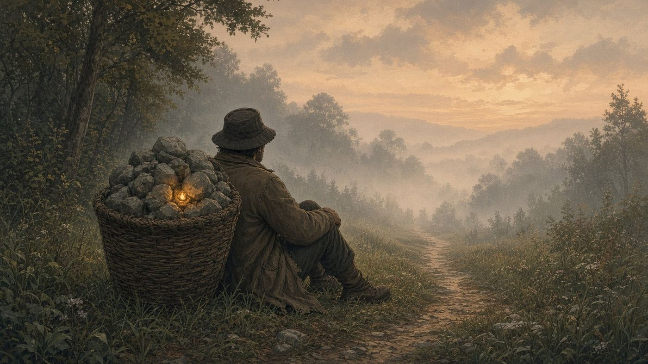
SAY IT PLAINLY Everything a Traveler is still carrying or has not fully examined.
PICTURE THIS A basket containing many ordinary Stones. Only one may need attention today.
DO NOT CONFUSE IT WITH A problem list, a diagnosis, or proof that everything must be processed.
The Quarry holds what is still being carried.
TRAVELS WITH Traveler; Raw Stone; Wonder Break

II. One Traveler Turns What Surfaced
05 PREFORMING WHEEL CONVERSATION-FIRST ORIENTATION
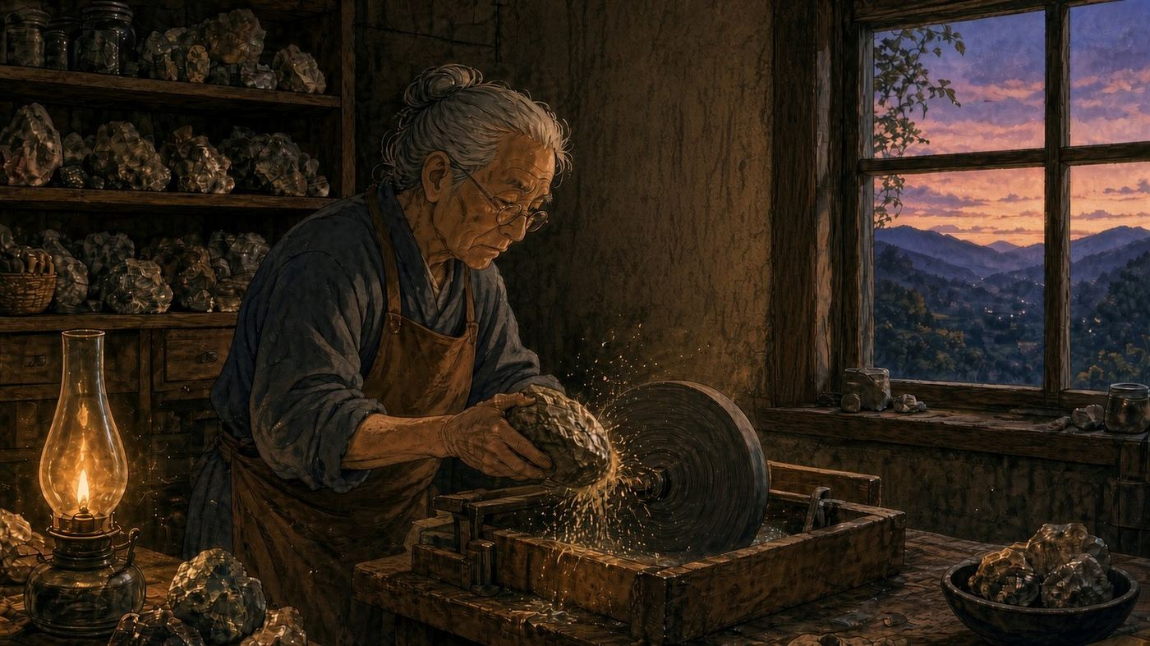
SAY IT PLAINLY The named opening process that helps a Traveler start talking before the Raw Stone is fully named.
PICTURE THIS The Traveler speaks about what has been occupying attention. The Guide listens for repeated language, tensions, and possible Raw Stones without forcing one conclusion.
DO NOT CONFUSE IT WITH A personality test, intake form, diagnosis, strengths assessment, or requirement to know the right question before beginning.
The Preforming Wheel prepares the Stone. The Wonder Break turns it.
TRAVELS WITH Start Talking†; AI; AI Attunement; Raw Stone

06 WONDER BREAK INDIVIDUAL PRACTICE

SAY IT PLAINLY One person slows down and turns what has surfaced.
PICTURE THIS A Traveler creates enough room to look again, receive perspective, make meaning, and choose whether to keep, release, pause, preserve, or carry nothing forward.
DO NOT CONFUSE IT WITH Therapy, interrogation, advice-giving, forced vulnerability, or a promise that every session produces wisdom.
One person slows down and turns what they have been carrying.
TRAVELS WITH Preforming Wheel; Raw Stone; Traveler Artifact; Pause Artifact

07 RAW STONE INQUIRY

SAY IT PLAINLY An unrefined question, tension, memory, assumption, challenge, or possibility that still contains something worth turning. During inquiry, the first Raw Stone may reveal a deeper or more regenerative Raw Stone.
PICTURE THIS The Traveler begins with something carrying unresolved energy. Turning may reveal that the question underneath deserves the deeper attention.
DO NOT CONFUSE IT WITH The person, project, or experience itself; a finished answer; or an insight already proven valuable.
The first Stone we turn may not be the Stone where the inquiry rests.
TRAVELS WITH Surface Stone†; Quarry; Wonder; Perspective

08 REGENERATIVE LEARNING HABITS LEARNING ARCHITECTURE

Wonder invites you to take a closer look.
SAY IT PLAINLY Eight named habits practiced through Memory Stones: Wonder, Perspective, Reflection, Do It Scared, I Am Here, Connection, Wisdom, and Innovation.
PICTURE THIS The habits are lived inside the conversation, then recognized afterward through the Artifact.
DO NOT CONFUSE IT WITH A rigid sequence, personality profile, score, or checklist that must be completed every time.
The conversation builds the experience. The Artifact builds recognition. Repetition builds capability.
TRAVELS WITH Wonder Break; Traveler Artifact; Experience First, Recognition Afterward†

09 WONDER REGENERATIVE LEARNING HABIT

SAY IT PLAINLY Curiosity before conclusion.
PICTURE THIS A Traveler loosens certainty long enough to ask what else may be present.
DO NOT CONFUSE IT WITH Naivety, endless questioning, or refusing to make decisions.
Wonder interrupts certainty.
TRAVELS WITH Wonder Portal; Perspective

10 PERSPECTIVE REGENERATIVE LEARNING HABIT

SAY IT PLAINLY Turning the Stone and looking again from another position.
PICTURE THIS A second angle reveals a mark, assumption, relationship, or possibility hidden from the first view.
DO NOT CONFUSE IT WITH Someone else owning, fixing, or overruling the Traveler's experience.
A Stone has more than one side.
TRAVELS WITH Wonder Walk; Reflection

11 REFLECTION REGENERATIVE LEARNING HABIT

SAY IT PLAINLY Making meaning from what the turning revealed.
PICTURE THIS The Traveler asks what the experience is teaching and what has changed in understanding.
DO NOT CONFUSE IT WITH Rumination, replaying events without purpose, or forcing a positive lesson.
Reflection helps us understand what the turning reveals.
TRAVELS WITH Perspective; Wisdom

12 DO IT SCARED REGENERATIVE LEARNING HABIT
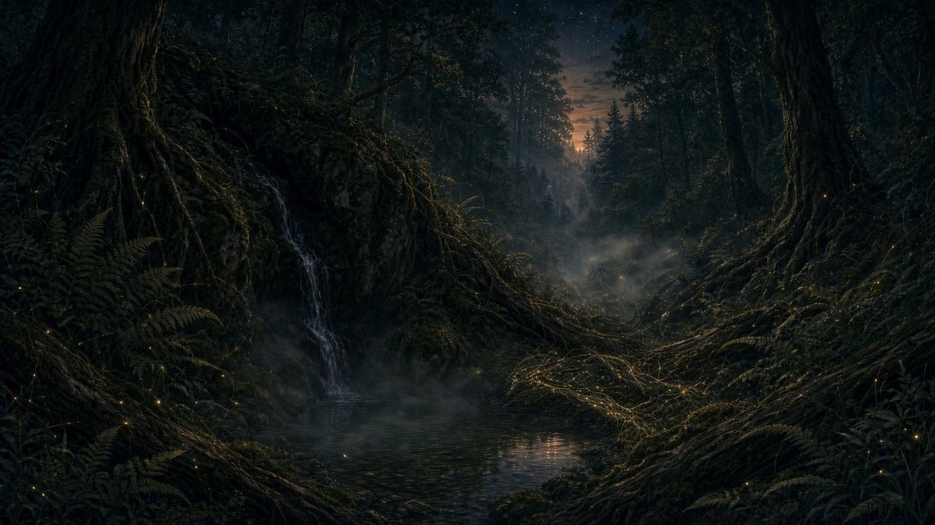
Sometimes a path asks to be formed.
SAY IT PLAINLY Remaining honestly engaged while fear or uncertainty is still present.
PICTURE THIS The Traveler names what matters or considers a small next step without waiting for fear to disappear.
DO NOT CONFUSE IT WITH Recklessness, pressure, overexposure, hustle, or pretending fear does not matter.
Fear can ride along without steering.
TRAVELS WITH I Am Here; Innovation

13 I AM HERE / OBSERVER CHECK REGENERATIVE LEARNING HABIT
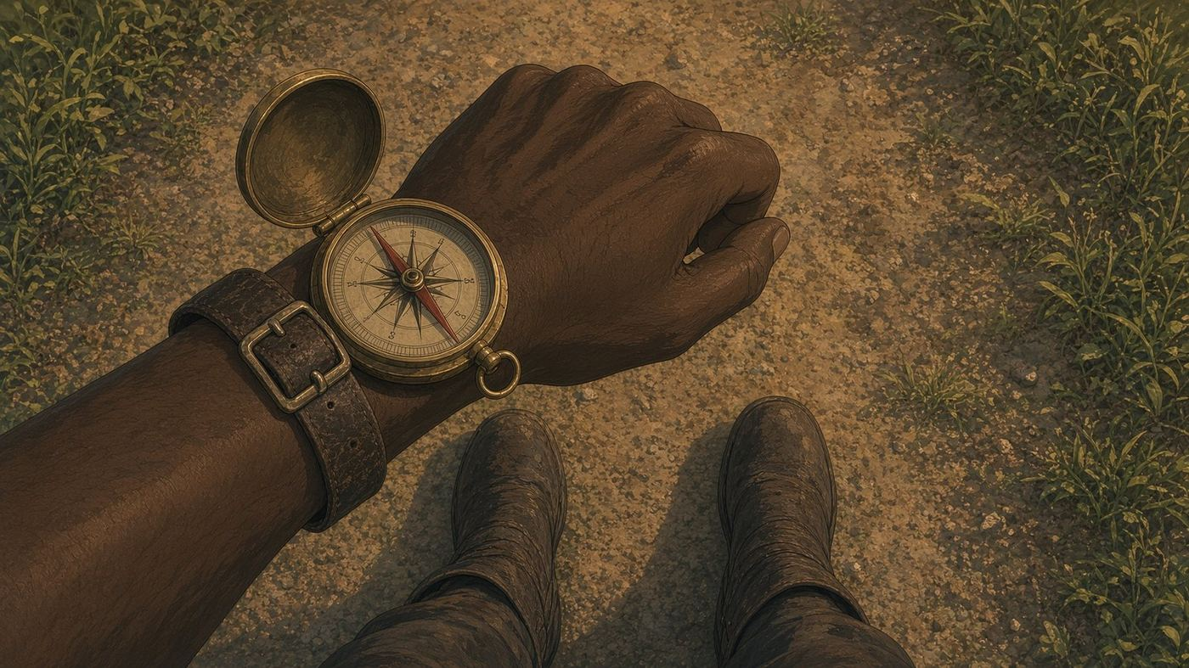
SAY IT PLAINLY Returning to what is actually present before choosing what comes next.
PICTURE THIS The Traveler notices the current truth, separates observation from prediction, and regains bearings.
DO NOT CONFUSE IT WITH Mindfulness theater, emotional suppression, or claiming certainty about the future.
The next step begins with I Am Here.
TRAVELS WITH Do It Scared; Connection

14 CONNECTION REGENERATIVE LEARNING HABIT

One path. Many lives. The question becomes clearer in a larger landscape.
SAY IT PLAINLY Recognizing how the inquiry relates to people, history, place, systems, or other lived experience.
PICTURE THIS One Stone becomes understandable in relationship to a larger landscape.
DO NOT CONFUSE IT WITH Forced networking or treating every person as a resource.
Wisdom becomes clearer in relationship.
TRAVELS WITH Wonder Walk; Wonder Workshop; Bridge

15 WISDOM REGENERATIVE LEARNING HABIT

SAY IT PLAINLY Discerning what may be worth carrying forward.
PICTURE THIS The Traveler separates what happened from what the experience may teach.
DO NOT CONFUSE IT WITH A beautiful sentence, instant truth, universal advice, or automatic Memory Stone.
Wisdom is knowing what is worth carrying.
TRAVELS WITH Memory Stone Candidate; Traveler Artifact

16 INNOVATION REGENERATIVE LEARNING HABIT

SAY IT PLAINLY Allowing wisdom to open a life-giving possibility, experiment, action, or new question.
PICTURE THIS A better understanding changes what might be tried or imagined next.
DO NOT CONFUSE IT WITH Novelty, forced productivity, guaranteed invention, or a required outcome.
Innovation begins when wisdom becomes generative.
TRAVELS WITH Do It Scared; Field Use Evidence

III. The Path Widens
17 WONDER WALK RELATIONAL PRACTICE

SAY IT PLAINLY Two people walk together while each turns a separate Stone and works a separate Quarry.
PICTURE THIS Each Traveler keeps ownership. Another position helps reveal a side that was difficult to see alone.
DO NOT CONFUSE IT WITH One person coaching, fixing, carrying, or interpreting the other person's Stone.
We each turn our own Stone, but we do not have to turn it alone.
TRAVELS WITH Perspective; Connection; Fellowship of Curiosity

18 WONDER WORKSHOP SHARED-INQUIRY PRACTICE
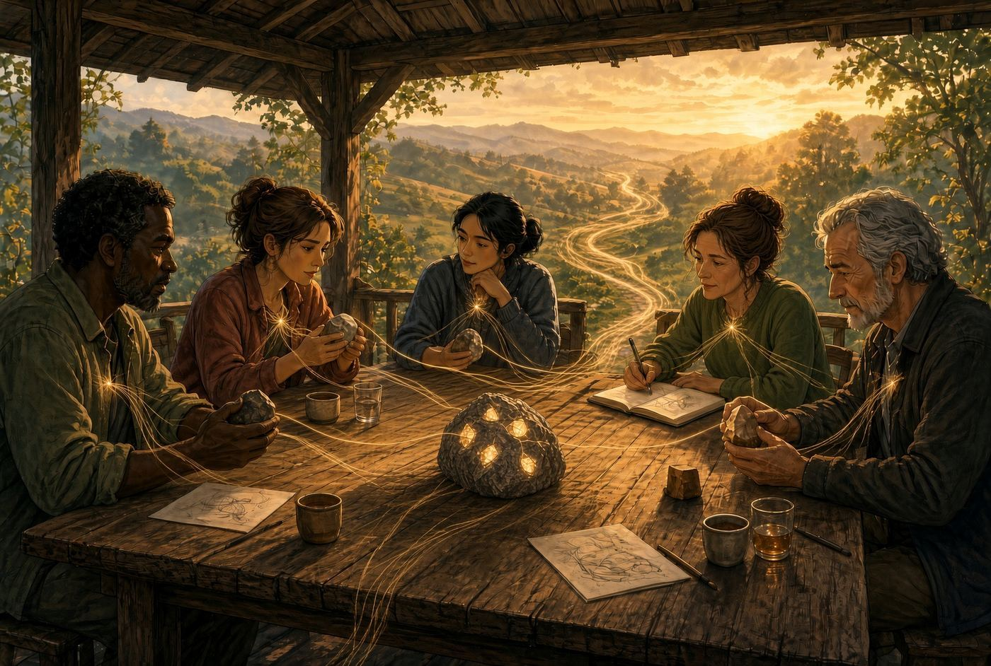
SAY IT PLAINLY Three or more people bring distinct lived perspectives and personal Stones to one shared inquiry.
PICTURE THIS A rough shared question sits at the center while different lives reveal different facets.
DO NOT CONFUSE IT WITH Consensus theater, brainstorming volume, one expert's answer, or a requirement to resolve the inquiry.
Different lives reveal different sides of the same question.
TRAVELS WITH Wonder; Perspective; Raw Stone

19 FELLOWSHIP OF CURIOSITY RELATIONAL COMMUNITY
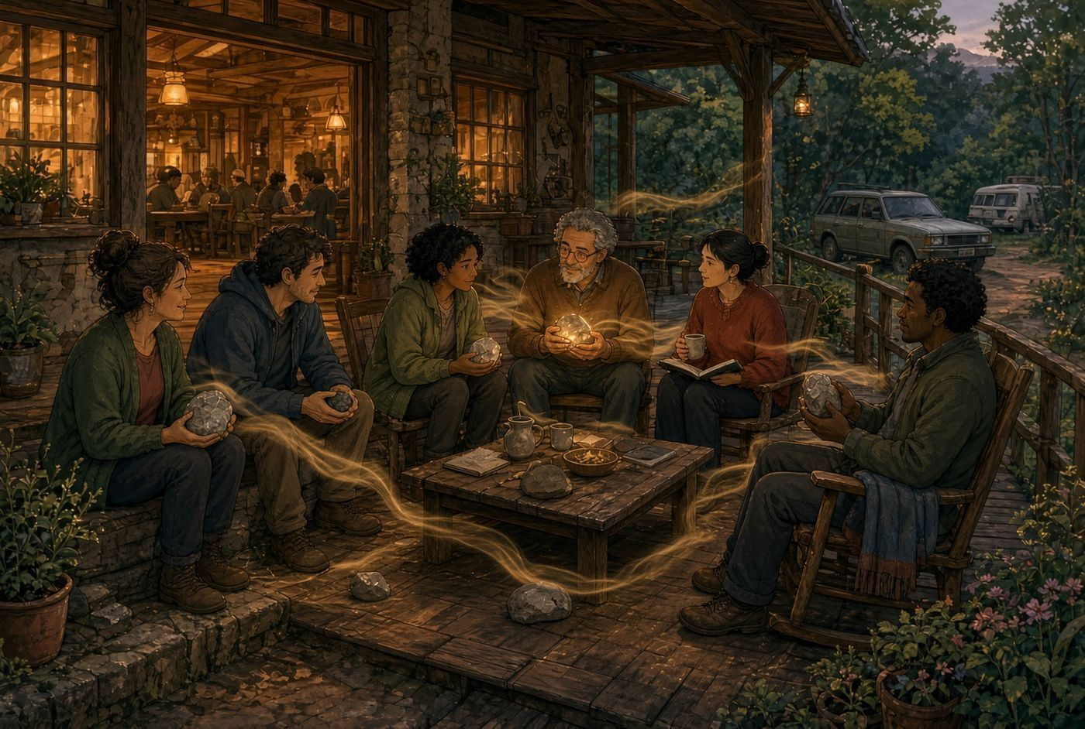
SAY IT PLAINLY The living network of relationships formed by people who choose to wonder, listen, preserve wisdom, and help one another keep walking.
PICTURE THIS One person wonders. Two walk together. Several gather. Relationship accumulates across the practices.
DO NOT CONFUSE IT WITH Another organizational structure, membership hierarchy, rank, or mandatory community.
The Fellowship is the community growing between the practices.
TRAVELS WITH Wonder Break; Wonder Walk; Wonder Workshop; The Hearth

20 THE HEARTH COMMUNAL PRACTICE / GATHERING
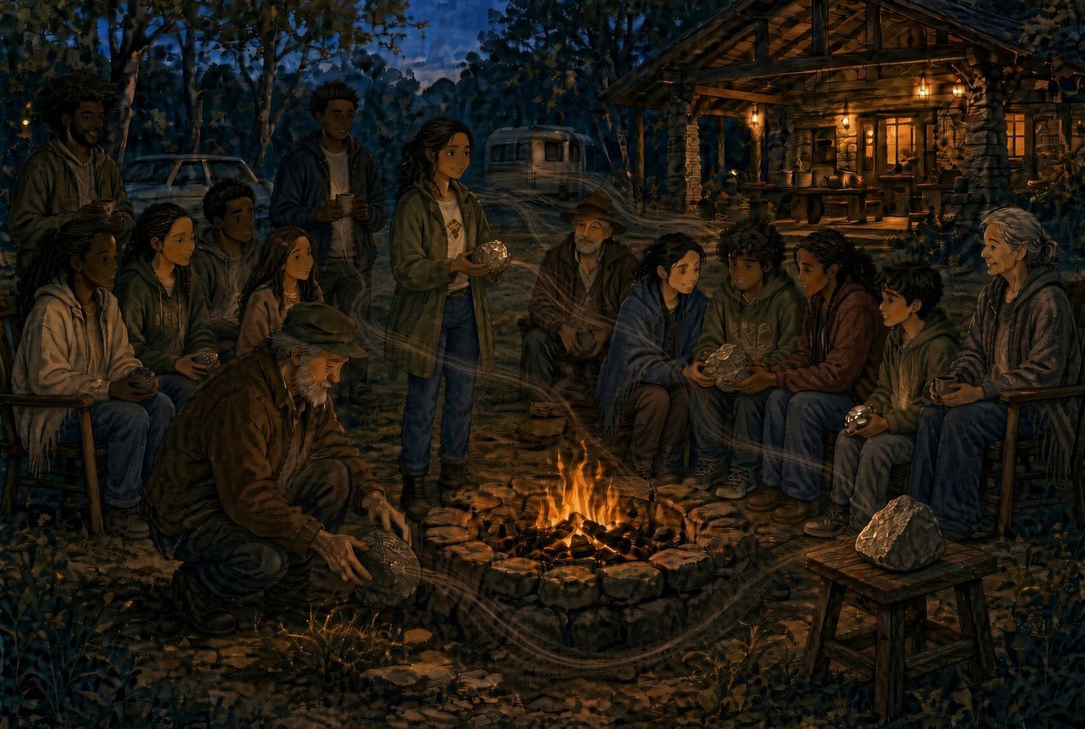
SAY IT PLAINLY A recurring gathering where some paths meet through conversation, food, music, creativity, storytelling, celebration, reflection, recognition, and voluntary wisdom-sharing.
PICTURE THIS Some people share. Some pause. Some release. Some keep things private. The community remains hospitable to all four.
DO NOT CONFUSE IT WITH The whole of Memory Stones, a ceremony, conference, mandatory sharing circle, or place where the fire judges the Stones.
The Fellowship is the community. The Hearth is one place it gathers.
TRAVELS WITH Fellowship of Curiosity; Stewardship†; Bridge

IV. What Is Kept, Released, or Carried
21 TRAVELER ARTIFACT TRAVELER-OWNED REFLECTIVE MAP
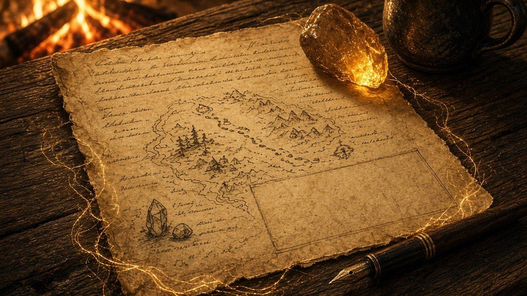
SAY IT PLAINLY A one-page record of what the Traveler carried, what became clearer, and what may be worth remembering.
PICTURE THIS After the experience, the page helps the Traveler recognize the named practices that occurred.
DO NOT CONFUSE IT WITH A diagnostic report, transcript replacement, performance record, proof that every pathway movement occurred, or consent to archive.
The conversation builds the experience. The Artifact builds recognition.
TRAVELS WITH Experience First, Recognition Afterward†; Consent

22 PAUSE ARTIFACT TRAVELER-OWNED PAUSE RECORD

SAY IT PLAINLY A one-page record preserving what became clearer, what remains unfinished, and where inquiry may continue without forcing resolution.
PICTURE THIS The exact place of an honest pause is marked so the Traveler may return or permit another perspective to enter later.
DO NOT CONFUSE IT WITH A failed Traveler Artifact, abandoned work, incomplete homework, or disguised answer.
Unfinished does not mean unsuccessful.
TRAVELS WITH Meaningful Non-Completion; Bridge Artifact

23 MEANINGFUL NON-COMPLETION METHODOLOGY GUARDRAIL

SAY IT PLAINLY The recognition that clarified uncertainty may be a responsible and useful outcome.
PICTURE THIS A session ends with a better question, mapped constraints, or an honest pause rather than manufactured Wisdom.
DO NOT CONFUSE IT WITH Giving up, poor facilitation, or failure to complete a required pathway.
A Wonder Break may pause without failing.
TRAVELS WITH Pause Artifact; Candidate Before Claim

24 MEMORY STONE CANDIDATE CANDIDATE WISDOM
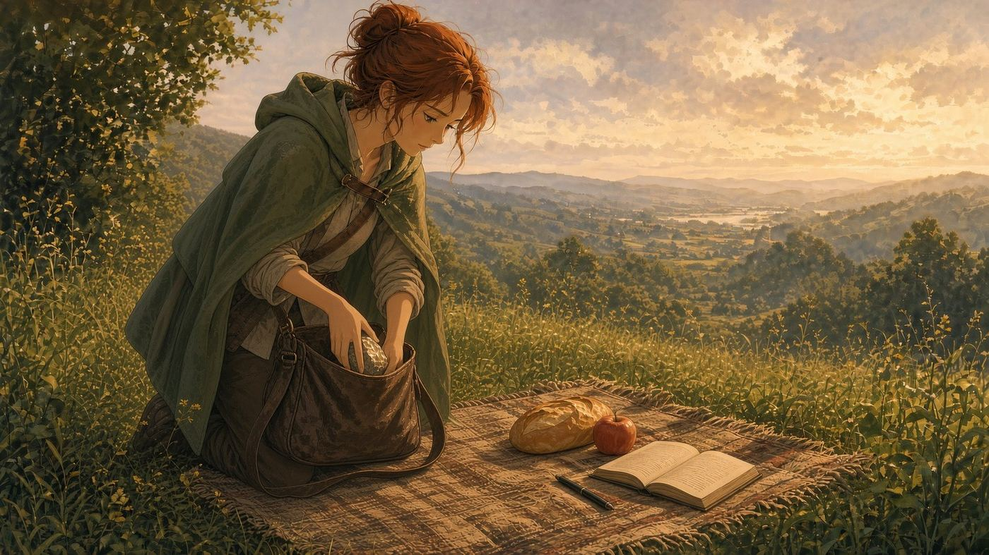
SAY IT PLAINLY A possible piece of wisdom worth remembering and testing.
PICTURE THIS A phrase or lesson catches light, but the Traveler and future evidence still need to test whether it carries weight.
DO NOT CONFUSE IT WITH A confirmed Memory Stone, universal truth, award, or wisdom established because the language sounds powerful.
A Stone may catch the light before anyone knows whether it can carry weight.
TRAVELS WITH Candidate Before Claim; Field Use Evidence

25 MEMORY STONE WISDOM THAT CONTINUES GUIDING
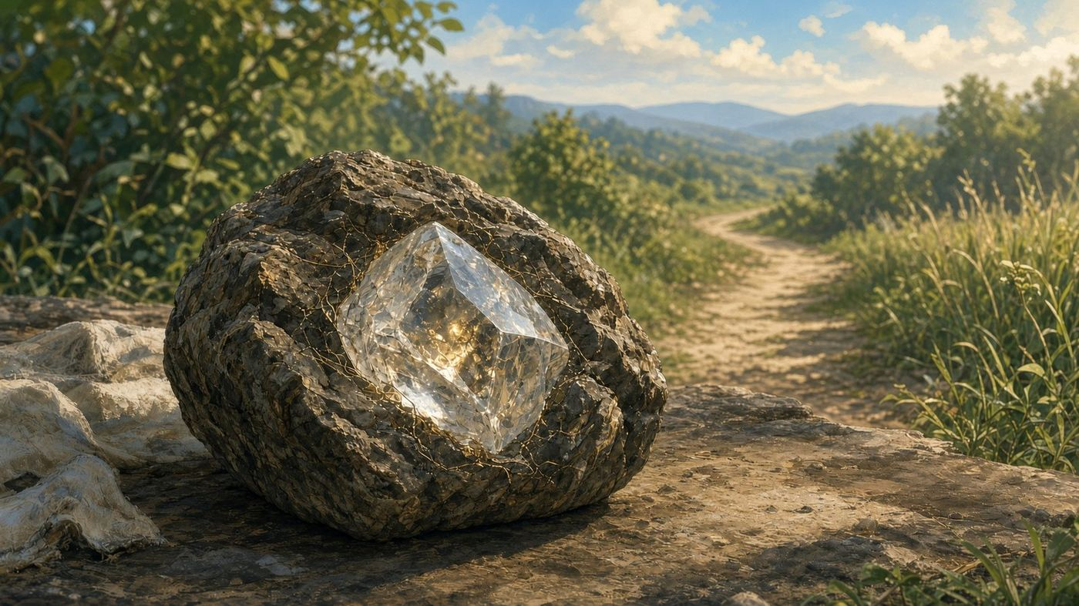
SAY IT PLAINLY A lesson rooted in lived experience that remains memorable, useful, and active in what comes next.
PICTURE THIS A lesson returns later and meaningfully guides a decision, reflection, action, or new inquiry.
DO NOT CONFUSE IT WITH A memory, quote, slogan, topic, person, project, or automatically shareable organizational asset.
A Memory Stone is a lesson that refuses to be forgotten because it continues to guide what comes next.
TRAVELS WITH Memory Stone Candidate; Memory Stone Loop; Field Use Evidence

26 MEMORY STONE LOOP REGENERATIVE RE-ENTRY PRACTICE

SAY IT PLAINLY A returning Memory Stone is turned again to see what the wisdom may teach now.
PICTURE THIS Something once useful returns in a changed context and may reveal a new Raw Stone, new Candidate, or no further work.
DO NOT CONFUSE IT WITH Recycling every insight forever, rumination, forced reuse, or automatic promotion.
Every Memory Stone can become a new Raw Stone, but not every Memory Stone needs to.
TRAVELS WITH Raw Stone; Field Use Evidence; Legacy Signal†

27 LEGACY STONE ENDURING WISDOM
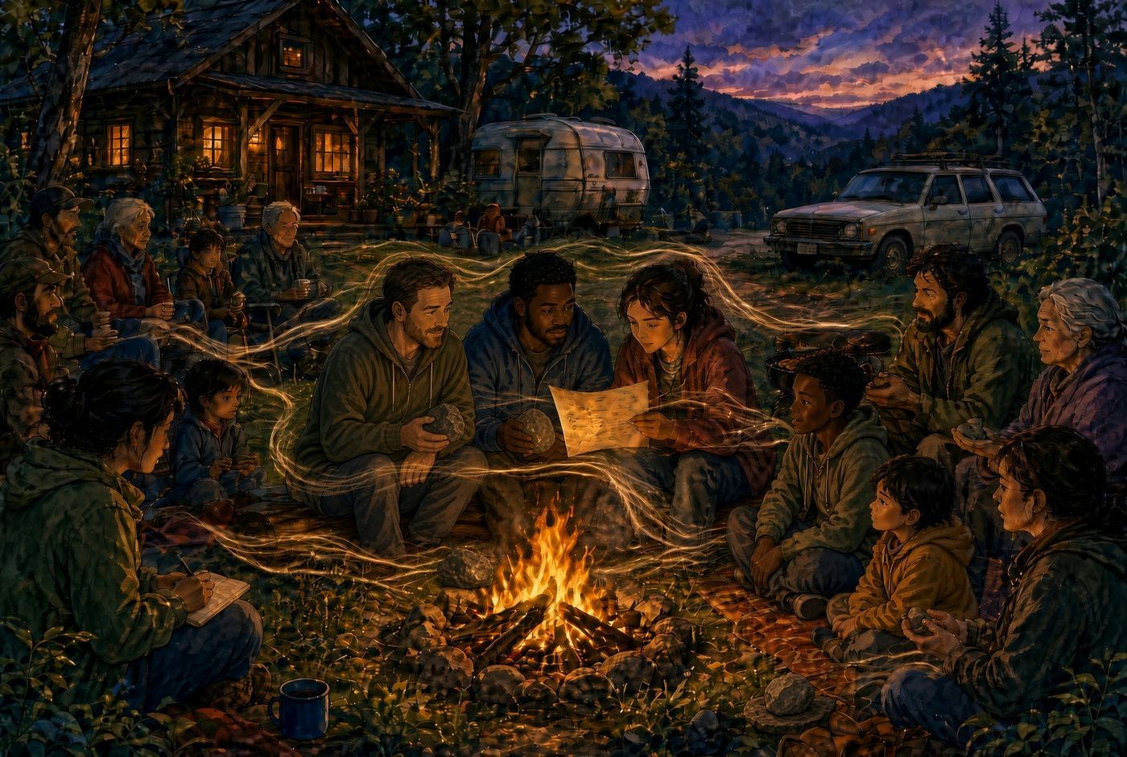
SAY IT PLAINLY A Memory Stone that has endured through time, use, people, or changing contexts and continues to serve.
PICTURE THIS Others remember, use, teach, adapt, or apply the wisdom beyond its original moment with context intact.
DO NOT CONFUSE IT WITH An old quote, retirement tribute, beautiful phrase, or candidate promoted because it feels important. Continued usefulness does not override consent or source context.
A Legacy Stone is preserved because it keeps serving.
TRAVELS WITH Legacy Stone Candidate†; Field Use Evidence; Vellichor

28 VELLICHOR LEGACY ARCHIVE-SPACE

SAY IT PLAINLY The named inner archive where confirmed Legacy Stones may be preserved, revisited, studied, and allowed to continue teaching.
PICTURE THIS An old library-like place where enduring wisdom remains alive through return and use.
DO NOT CONFUSE IT WITH The whole Curiosity Compendium, a storage dump, or a place every Stone automatically enters.
Vellichor is not where wisdom goes to sleep. It is where wisdom waits to be rediscovered.
TRAVELS WITH Legacy Stones Registry†; Curiosity Compendium

V. When an Inquiry Crosses
29 BRIDGE CONSENT-AWARE CONTINUATION
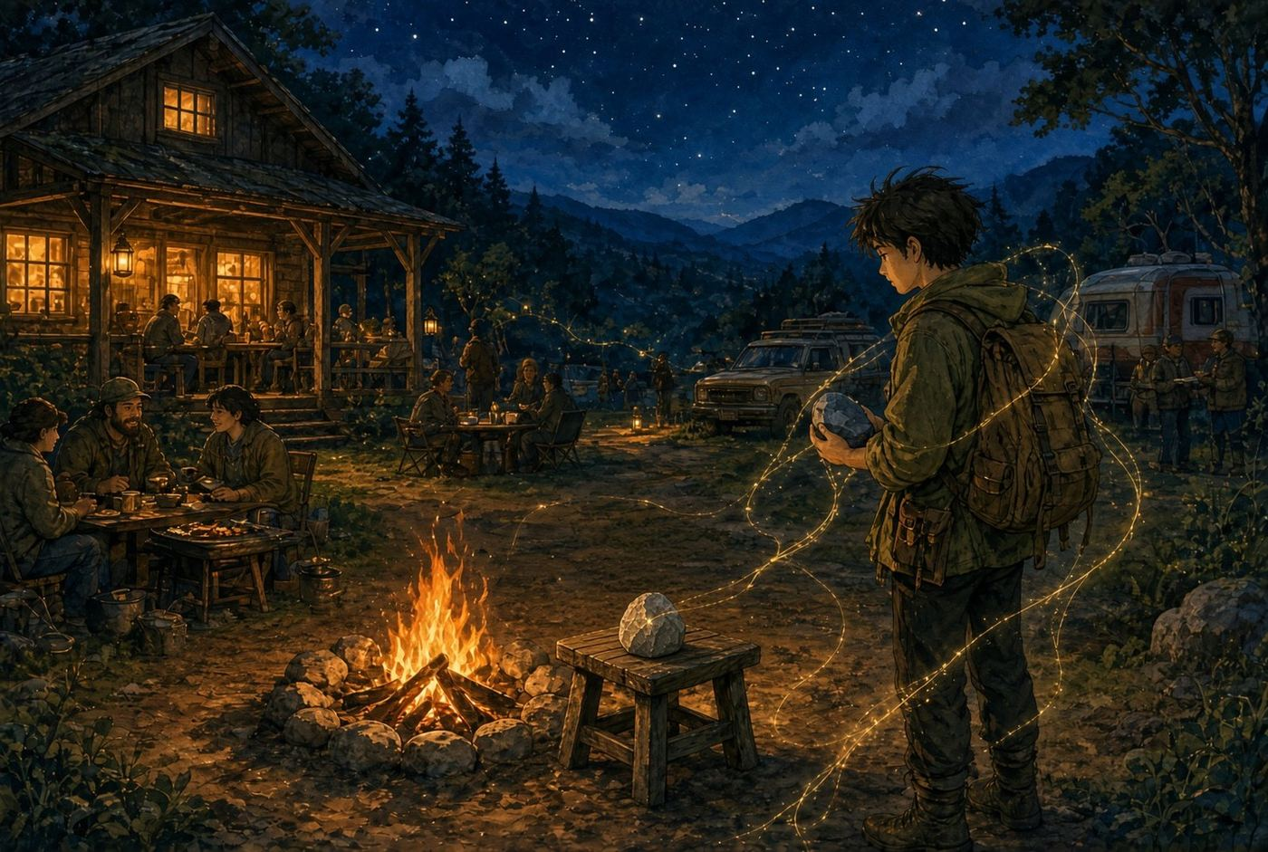
SAY IT PLAINLY The movement that begins when something unfinished in one Traveler connects with something another Traveler already carries.
PICTURE THIS A preserved inquiry catches another person's curiosity. No assignment or transfer is assumed.
DO NOT CONFUSE IT WITH A mandatory handoff, ownership transfer, destiny, or one person improving the other person's idea.
A Bridge begins with curiosity, not assignment.
TRAVELS WITH Pause Artifact; Bridge Artifact; Consent

30 BRIDGE ARTIFACT LINEAGE-PRESERVING RECORD
SAY IT PLAINLY A record of an unfinished inquiry crossing between Travelers and being carried further without erasing what came before.
PICTURE THIS The first perspective remains visible. A second perspective is added. The Raw Stone changes scale or reveals another side.
DO NOT CONFUSE IT WITH A merged summary, false consensus, ownership transfer, or proof of repeatability from one case.
One perspective is preserved. Another is added. Neither is erased.
TRAVELS WITH Bridge; Pause Artifact; Attribution†; Evidence†

31 BRIDGE STONE RELATIONAL WISDOM MARKER

SAY IT PLAINLY A person, relationship, project, place, or moment through which meaningful passage, opportunity, wisdom, protection, or direction entered a journey.
PICTURE THIS A mentor, invitation, conversation, or place altered what became possible and the wisdom of that crossing is preserved.
DO NOT CONFUSE IT WITH A biography, personality profile, endorsement, sponsor claim, or artifact handoff.
A Bridge Stone remembers what entered the journey through relationship.
TRAVELS WITH Fellowship Archive†; Consent; Source and Stone distinction†

VI. AI, Evidence, and Stewardship
32 AI TOOL
SAY IT PLAINLY A technology that may assist with conversation, organization, reflection, pattern suggestions, and Artifact drafting.
PICTURE THIS A tool helps hold volume while a human being retains meaning and judgment.
DO NOT CONFUSE IT WITH A Traveler, source of wisdom, facilitator with authority, decision-maker, therapist, or verifier of technical truth.
Human experience remains the source.
TRAVELS WITH AI Attunement; AI as the Sieve; Technical Verification†

33 AI ATTUNEMENT AI-SUPPORTED PRACTICE
SAY IT PLAINLY AI listens closely enough for what came before to change what comes next, while returning interpretation to the Traveler.
PICTURE THIS The Guide reflects possible meaning, the Traveler confirms, rejects, or refines what fits.
DO NOT CONFUSE IT WITH Flattery, imitation of empathy, mind reading, diagnosis, or AI declaring what the Traveler means.
AI offers the mirror. The Traveler names what is true.
TRAVELS WITH Guide Embodiment†; Traveler authority†

34 AI AS THE SIEVE VISUAL AND FUNCTIONAL METAPHOR
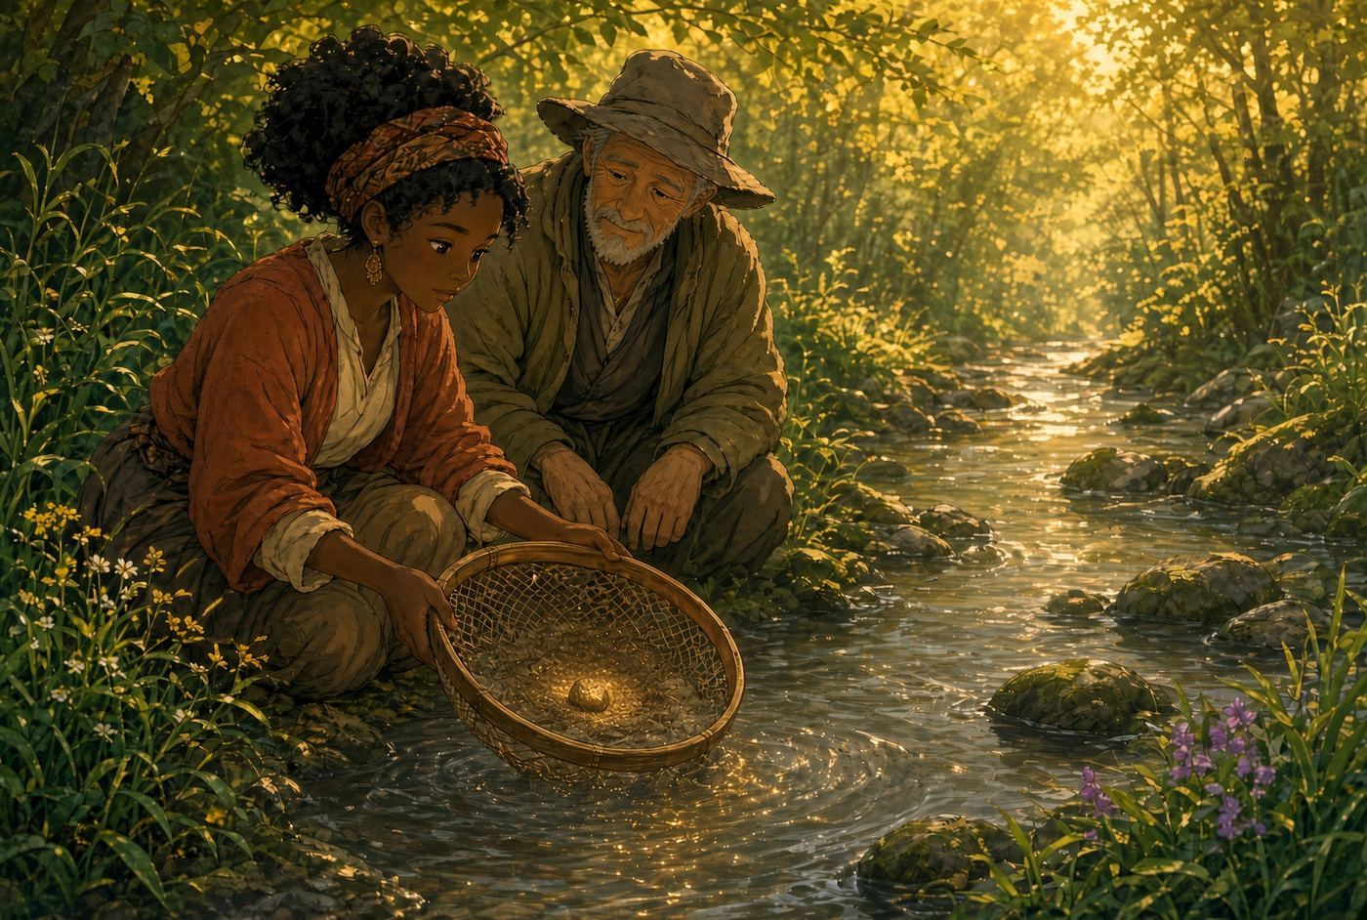
SAY IT PLAINLY AI helps make a large volume of conversation or material examinable so a possible glint can be noticed.
PICTURE THIS A person holds the sieve. The stream already contains the material. The person decides whether anything found has weight.
DO NOT CONFUSE IT WITH AI mining people for value, producing one giant answer, or creating wisdom from nothing.
AI helps the volume become examinable. It does not create the wisdom.
TRAVELS WITH AI Attunement; Artifact drafting†; Human review†

35 CANDIDATE BEFORE CLAIM STEWARDSHIP GUARDRAIL
SAY IT PLAINLY Use candidate language when something feels meaningful but has not yet been tested enough to carry authority.
PICTURE THIS A bright Stone remains on the table for turning rather than being installed as a monument.
DO NOT CONFUSE IT WITH Hesitation for its own sake or refusal to recognize genuine learning.
Let the Stone earn its name.
TRAVELS WITH Evidence Before Elevation; Memory Stone Candidate

36 EVIDENCE BEFORE ELEVATION STEWARDSHIP GUARDRAIL
SAY IT PLAINLY Promote an insight only when evidence shows that it continues serving beyond the first moment.
PICTURE THIS Repeated use, independent recall, changed decisions, or cross-context usefulness gradually add weight.
DO NOT CONFUSE IT WITH Counting enthusiasm, beauty, repetition by one person, or founder preference as proof.
Poetic resonance may reveal a candidate. Continued usefulness reveals weight.
TRAVELS WITH Field Use Evidence; Legacy Stones Registry†

37 FIELD USE EVIDENCE EVIDENCE TYPE
SAY IT PLAINLY Evidence that a Memory Stone was remembered, reused, quoted, applied, adapted, taught, or carried forward after the original experience.
PICTURE THIS Later, someone recognizes that a Stone still walks in a real conversation or decision.
DO NOT CONFUSE IT WITH Immediate resonance, a session count, a positive reaction, or proof of universal transferability.
A session may reveal a Stone. Field use helps show whether it still carries weight.
TRAVELS WITH Memory Stone; Legacy Signal†; Evidence Registry

38 CONSENT / STEWARDSHIP CHOICE TRAVELER PROTECTION
SAY IT PLAINLY The Traveler chooses what remains private, what may be preserved, whether attribution is allowed, and how far anything may travel.
PICTURE THIS At the end, the Traveler chooses: keep private, preserve personally, share anonymously, share within a defined group, attribute, or consider broader use after review.
DO NOT CONFUSE IT WITH A checkbox added after capture, blanket permission, participation, silence, public discussion, or Artifact creation.
Capture is not permission.
TRAVELS WITH Traveler Artifact; Pause Artifact; Bridge Artifact

39 NO EXTRACTION ETHICAL PRINCIPLE
SAY IT PLAINLY Memory Stones does not take stories or wisdom from people for organizational use. It helps people recognize value they already carry and choose whether anything is offered.
PICTURE THIS The practice serves the Traveler first. The Archive receives only what is voluntarily entrusted to it.
DO NOT CONFUSE IT WITH Content harvesting, performance evaluation, mandatory storytelling, surveillance, or treating people as data.
Protect the Traveler before preserving the insight.
TRAVELS WITH Trust Before Contribution†; Consent; Soul Protection Review†

40 SESSION REGISTRY / EVIDENCE REGISTRY EMERGING EVIDENCE INFRASTRUCTURE
SAY IT PLAINLY A structured record of what happened in a session, under what conditions, with what consent, and what remains unproven.
PICTURE THIS The registry remembers the practice conditions so later claims can be traced and reviewed.
DO NOT CONFUSE IT WITH A participant scorecard, surveillance system, impact proof, or reason to count sessions as success.
The registry remembers the conditions under which wisdom may have emerged.
TRAVELS WITH Evidence types†; Founder involvement†; Consent; Field Use follow-up†

VII. The Living Archive
41 CURIOSITY COMPENDIUM OPERATING SYSTEM AND LIVING ARCHIVE
SAY IT PLAINLY The body of work that preserves the rules of care and the discoveries produced through Memory Stones.
PICTURE THIS One part protects how the system works. Another part holds what the journey has revealed.
DO NOT CONFUSE IT WITH A finished encyclopedia, database that owns people's stories, or first document every newcomer must read.
The Operating System holds the rules of care. The Archive holds the living discoveries.
TRAVELS WITH Stone Archive†; Pattern Library†; Quarry; Wisdom Wellspring; Founder Archive†

42 FIELD NOTE EARLY OBSERVATION
SAY IT PLAINLY A raw or lightly refined observation captured before the moment disappears.
PICTURE THIS A sentence, quote, question, or small change is recorded without claiming what it ultimately means.
DO NOT CONFUSE IT WITH A confirmed Pattern, Memory Stone, or final interpretation.
Field Notes remember what was noticed before certainty arrived.
TRAVELS WITH Quarry; Pattern Library†; Session Registry

43 CAIRN WISDOM CLUSTER
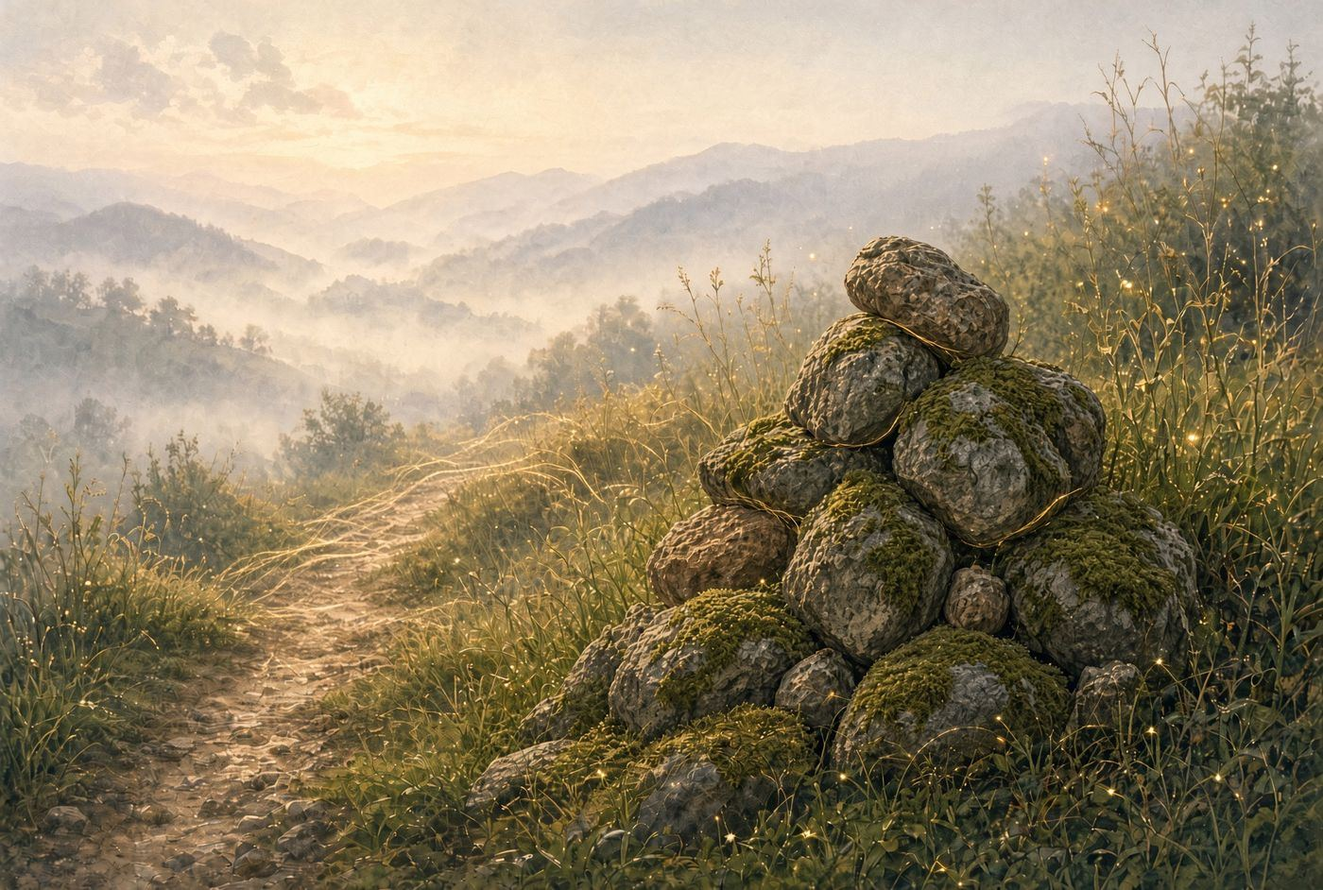
SAY IT PLAINLY A gathered cluster of related Stones, Field Notes, Raw Stones, patterns, and questions around a shared theme, project, season, relationship, or body of learning.
PICTURE THIS Related discoveries are placed near one another so they can be studied in relationship.
DO NOT CONFUSE IT WITH A Stone type, final conclusion, random folder, or proof that nearby entries form a pattern.
A Cairn gathers the Stones that belong near one another.
TRAVELS WITH Pattern Loop; Cross-Reference Map†; Quarry

44 PATTERN LOOP CAIRN REVIEW PRACTICE
SAY IT PLAINLY The reflective practice used to turn a Cairn and examine recurrence, relationships, tensions, edges, and emerging wisdom.
PICTURE THIS The gathered Stones are reviewed together to see what may be repeating and what still needs evidence.
DO NOT CONFUSE IT WITH A process for forcing coherence or automatically promoting a Pattern, Legacy Stone, or Keystone.
A Pattern Loop turns the Cairn to see what the gathered Stones may be teaching together.
TRAVELS WITH Cairn; Pattern Library†; Evidence Before Elevation

Candidate Before Claim. Evidence Before Elevation. Consent Before Archive.
Experience first. Recognition afterward.

